Portion Scale Slicer

  - 6/13/2019
  - Eric Landes

Button Toggle
Button Toggle inverts the main window buttons when they are pressed. This allows the user to more easily tell when a button is pressed.

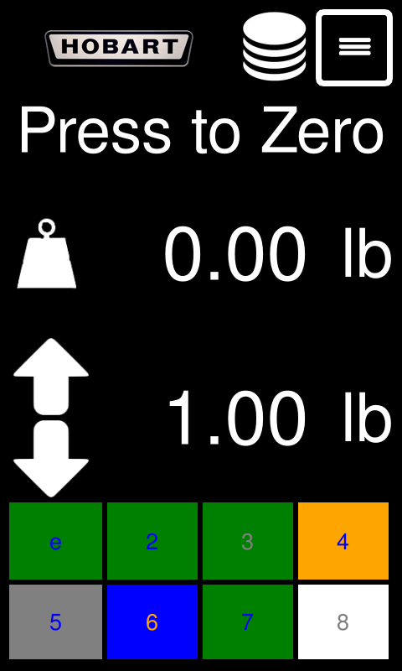
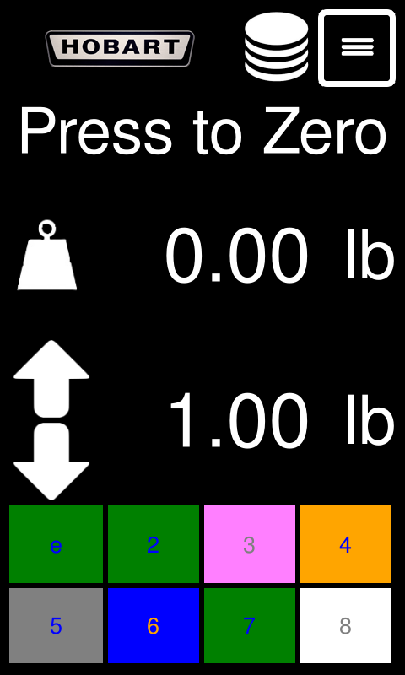
Figure 4: The "3" speedkey is released
Figure 1:The "3" speedkey is released
Figure 3: The "3" speedkey is pressed
Figure 2: The "3" speedkey is pressed

Infinity Mode
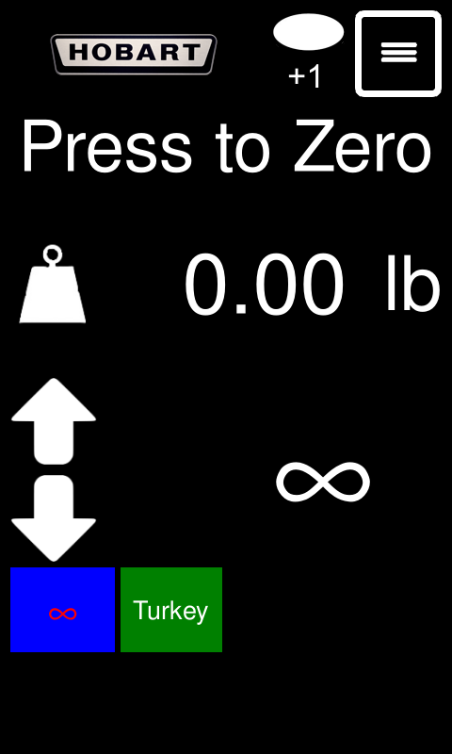
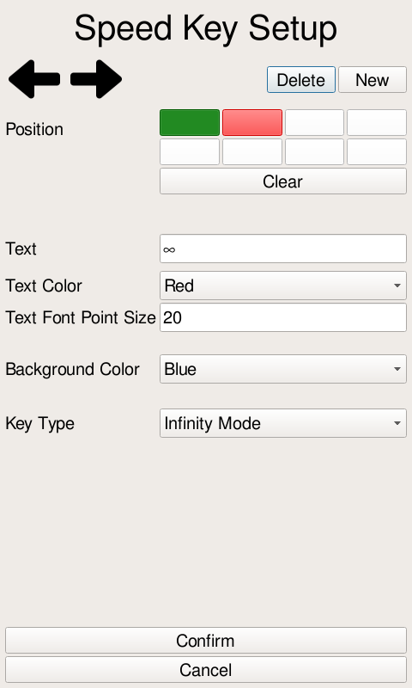
Infinity mode allows the user to run the slicer without it stopping on a weight setpoint. This mode is indicated by an infinity “∞” symbol appearing for the weight setpoint. Infinity mode can be entered three ways. The user can put the setpoint at the maximum setpoint value and then press the setpoint up key one more. Likewise, the user can set the setpoint at 0 and then press the setpoint down key. The final way to enter infinity mode is through a speedkey. In the speedkey configuration menu the “Key Type” field can be set to “Infinity Mode”. The user can then press the configured speed key to enter infinity mode. To exit infinity mode press the setpoint up or down key or change the setpoint using the speedkey
(Left) Figure 3: An example configuration for an Infinity Mode speed key
(Right) Figure 4: A slicer in Infinity Mode

Target Weight Tolerance
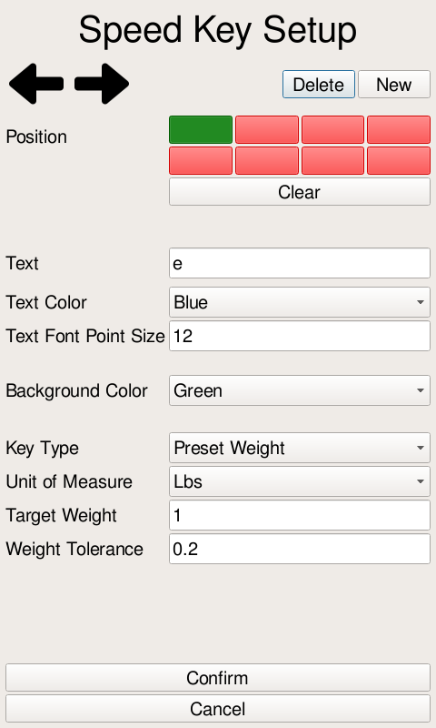
Target weight tolerance allows the user to set a tolerance for the setpoint. It is only available for use with speed keys. If a tolerance is set the slicer will stop running when the weight is within the tolerance. Configuring a tolerance of 0 will force the weight to meet the target weight. In stacking mode each stack will meet the tolerance requirement. When configuring the speedkey the weight tolerance must be less than the target weight.
Figure 5: The added field to set the target weight tolerance

Slicer Running Timeout
The slicer has a 30 second running timeout. If the slicer runs for 30 seconds without detecting any weight change on the platter it will automatically pause the slicer. Additionally, if the slicer runs for 30 seconds without reaching a stable weight the slicer will pause. This timeout can be disabled in the service slicer configuration menu. The timeout is not enabled in manual mode.
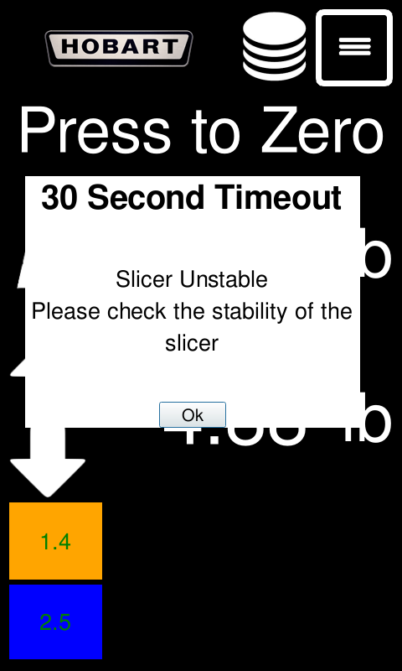
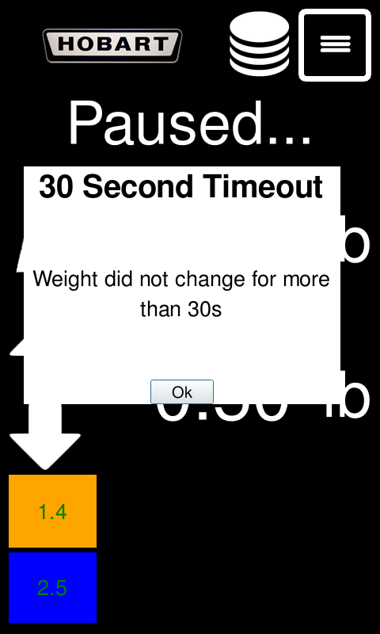
Figure 7 : (Left) The popup shown when the weight does not change for more than 30s
Figure 6: (Right) The popup shown when the weight is unstable for more than 30s

Weight Breaks
Instead of setting up weight breaks we opted to allow the weight setpoint keys to be held down. While the key is being held the weight setpoint will continuously increase or decrease until he key is released.

User Access
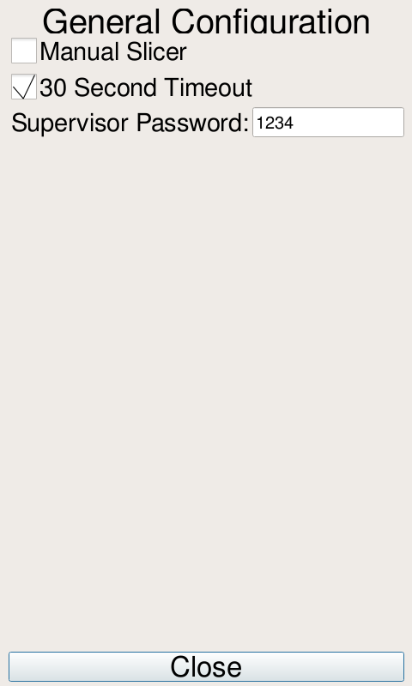
In the service settings, a user can choose to set a password to access the supervisor pages. The configuration field can be found under service >> setup utility >> configure slicer.

Maintenance Stats
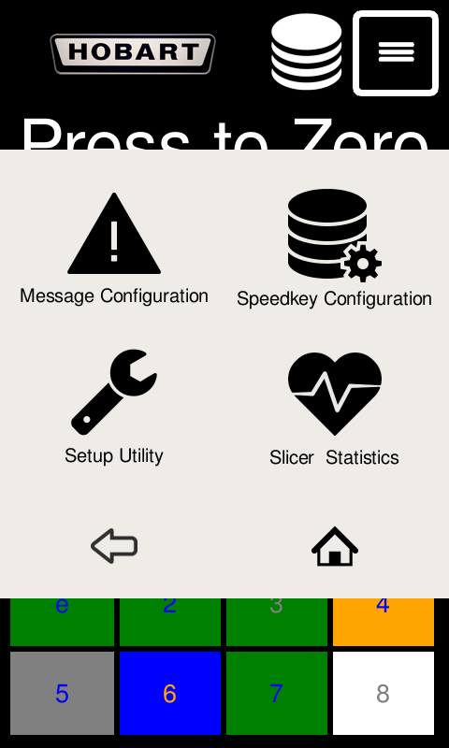
Maintenance and general statistics have been added to the Slicer Statistics menu. The menu is located under supervisor settings. In the Slicer Statistics menu you can find total slicing time in hours, total weight sliced in pounds, pounds sliced under each speedkey, and last time a user configured message was acknowledged.
Figure 8: The newly added Slicer Statistics menu

